Task2.1 Find the expression of group delay τ(ω) of series resonant circuit. Use the transfer function H(jω)=Ur1(jω)/Uin(jω).

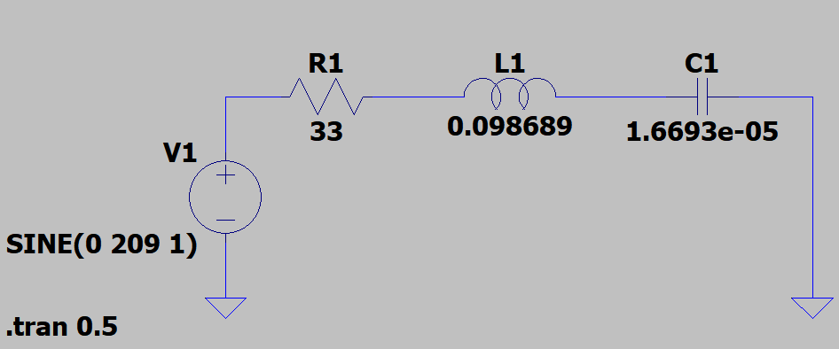

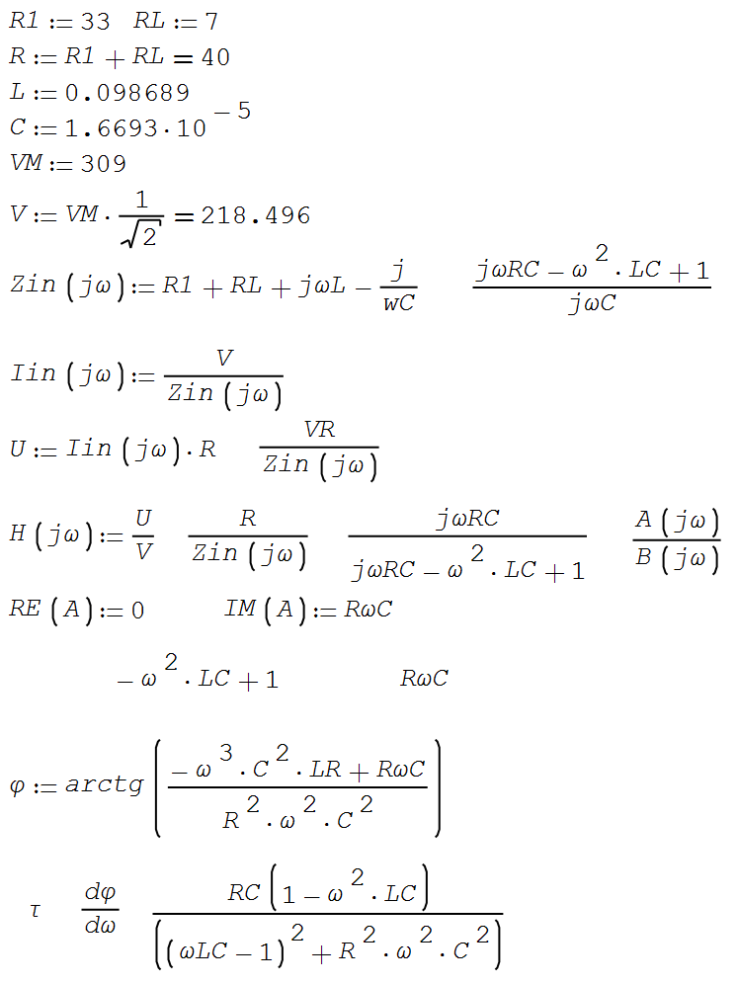



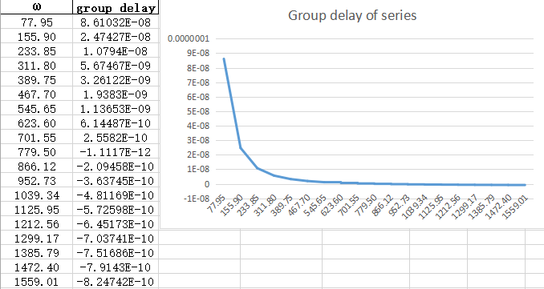

Task 2.2. Find the expression of group delay of parallel resonant circuit. Use the transfer function H(jω)=Ur1(jω)/Uin(jω).

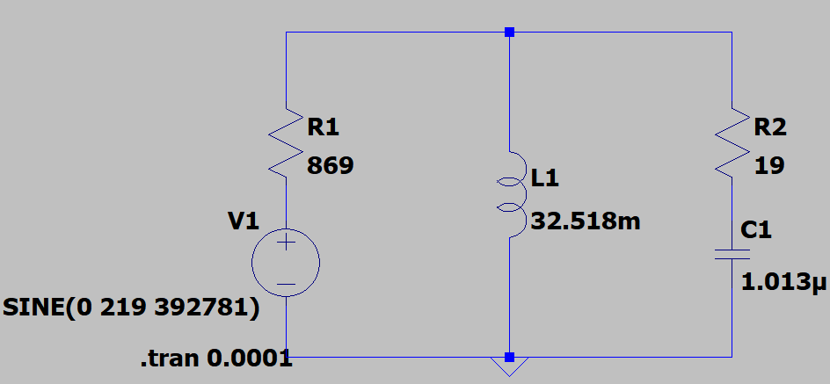

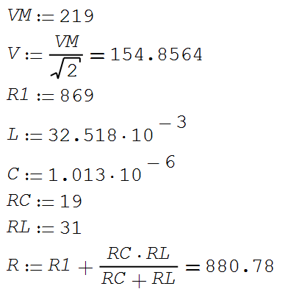

Let’s set **jω** as **s**

